2003-2004 ATHLETICS SEASON REVIEW
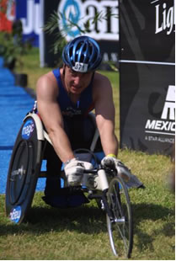

I realise you may all wonder exactly what’s happened to me – it’s been so long since I put pen to paper. Well I can assure you I am very well, training hard and competing around the four corners of the globe as usual.

2003 was a year of mixed fortunes for me. Having competed so well in 2002 to become the British Champion in the 100, 200, 400 and 800m at the HSA National Championships, then going on to represent Great Britain, finishing fourth in the ITU World Triathlon Championships in Mexico, I was hoping for even greater things in 2003.

However, in a way I became a victim of my own success. Having given my all throughout the 2002 athletics season and in Mexico in November, I spent the best part of three months struggling to train, plagued with fatigue and illness. By late February things were finally starting to come together as I flew off to Atlanta to have a new racing chair made, courtesy of Proctor and Gamble. It was an exciting time, and the initial signs were promising as I set a new personal best of 17.23s in the 100m at the Scottish Championships in April.

Due to my difficult winter I opted not to push things too hard and had to miss the London Marathon. At the time it was heart breaking, but in a way my absence added extra fuel to my fire for the marathon this year. Anyway, it turned out to be a season filled with somewhat average performances rather than raising my game to the next level. There were of course some highlights including winning the Leeds Half Marathon, four silver medals at the HSA National Championships and a personal best time in the Great North Run, finally breaking that illusive 60 minute barrier.
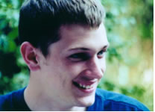
However, the year was somewhat overshadowed by the death of my work colleague and close friend Oliver Mills. He was tragically killed when a car pulled out of a junction directly in his path and his motorcycle collided with the vehicle on 20th August. I will never forget that day, two work colleagues arrived at my house to break the news to me, and then disappeared almost as soon as they arrived, leaving me in a state of total disbelief. Oliver had been one of my greatest supporters and a constant source of inspiration and enthusiasm. Whilst I tried to carry on training and competing, as I knew that’s what he would have wanted, the emotion and underlying fatigue from Mexico left me drained and my performances suffered as a result.

After the Swiss Nationals in August I returned home, feeling more inspired than ever and set about planning my assault for 2004 along with my coach and mentor Simon Bassett. The first thing I needed to sort out was my position in the chair. Having observed some world class Swiss and Japanese athletes, and the design of their racing chairs, it was off down to Draft Wheelchairs, my head filled with ideas and possibilities. I spent a full day with them and worked out a new way of constructing the frame of the racing wheelchair to accommodate my feet in a better location. They then set about retrofitting my old chair as I took a month break from the rigours of training to allow my body and emotions some time to repair and recharge.

When I returned to winter training at the beginning of November in my modified chair the initial signs were incredibly positive. Draft had done an innovative job on my chair, orienting my body into an ideal pushing position, the rest had allowed me to return fully focused and with more passion and desire than ever before. That, combined with a slightly new approach to my strength and conditioning training meant that my winter training went extremely well and with great consistency.

This shone through in late November when I took part in The Academy’s indoor triathlon. While the able bodied entrants swam 20 lengths, cycled 5k on a stationary bike and ran 3k on a treadmill, I swapped the run for 8k on my training rollers, having completed the same distance in the pool. With the leaders time firmly in my sights I powered through the 8k to take the fastest overall time and received a special recognition award from Berry’s jewellers, who had supported the event. An old school friend of mine, Kirsten Richards, took the pictures shown left.
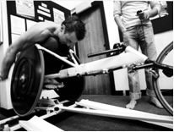

My first real test came in March at the Redcar 10 mile road race. As always it was extremely cold, and the usual strong wind gathered the sand from the shore, providing nature’s own exfoliating service to any exposed skin. It was an exciting race, with 2nd and 3rd place swapping between Brian Aldis and myself. Unfortunately the wind got the better of me and I managed to clip a police cone sending me down the road on my left arm and shoulder. Despite this I recovered to take a well deserved 3rd place.
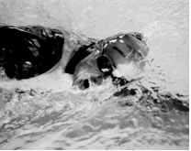

My luck continued in a similar vein in April, when I punctured at the half way point whilst leading the Wakefield 10k and had to withdraw.

However, later that month my luck took an upturn, and I was finally able to capitalise on the fitness and strength gains I had made over the winter, when I finished 6th in the London marathon in a personal best time of 2hrs 11s. It was a long and gruelling race that was hindered by several downpours, but while several racers suffered punctures from debris swept onto the course by the rain, my luck and nerve held strong.

I flew straight from London to Bron, France for a UK Athletics training camp. Unfortunately, I had sustained an injury slipping off the push rim in the rain in London, so was only able to complete a limited volume of training, spending more time with the physio and an ice pack.

The track season opened its doors in May, at the British Wheelchair Racing Association Track Championships and my first showing yielded two first places in the 200m and 400m, and a second in the 800m.

Having been the British number one in the 800m for the previous 2 years, I was not about to rescind this title lightly. This was never more evident in my next event in Warm Springs, Atlanta, where I smashed my personal best time and set a new British record of 1m 52.75s. This was a great race meet for me, where I also set new personal best times in the 400m and 200m. However, there was also some disappointment as this was the final chance to qualify for the Paralympics in Athens. My time of 29.66s in the 200m meant I just missed the qualifying standard of 29.5s by 0.16s. Rather than feeling disappointed I knew that my race had been far from perfect and that there was room for further improvement that would take me to the World stage.
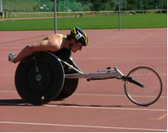
On my return from the States I raced at the DSE Open in Birmingham taken 1st place in the 800m and 2nd in the 400m and 200m.

The following weekend I travelled across the Pennines for the Great Manchester Race. My fatigue and jet lag were starting to show but I dug deep, having to fight continuously for the entire 10k, to secure 3rd place and another personal best time. At this point the rigours of training, travelling and racing hit home and it was time to ease back for a few weeks to regroup and refocus. I had to opt out of the Thirsk 10 mile road race to avoid total exhaustion, not something I find easy at all!

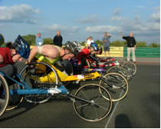
The Swiss National Championships came around just as my form was returning, but a slow track and wet weather did not help my form, or my times. My training partner surged past me in the 800m, bumping on the way, and beat me to the finish line. I held my form in the 200m and 400m, finishing as the first Brit, but I knew there would need to be yet more recovery time before I reached my peak again.

With some smart training over the following weeks I was able to take the Pit Stop 10k, at Croft racing circuit in style. It’s always been a great course for me, with fast sweeping bends and a long pit straight, and even driving up to the race I found my zone and had a feeling of invincibility that all athletes dream of, but seldom find. After the first lap of three I had a comfortable lead ahead of the field with just one other athlete in contention. This remained the same for the remainder of the race with me at the front working hard into the head wind. After all the hard work there was no way I was going to finish second and I produced a strong burst of speed to sprint across the line in first place. To the left are my favourite photos, taken by my friend Guy Cope.
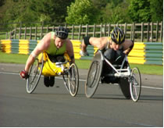

Then in early August I suffered an embarrassing meet at Kirkby in an open track event. It was a total anomaly after the Pit Stop 10k as my fitness was excellent. Somehow my head, or my heart, was elsewhere. I produced the worst series of races of my life. There was little consolation but I did manage to win the 10k in a personal best time.

So it was back to the drawing board, with just a few weeks to the last track competition of the season in Rivera, Switzerland. I worked tirelessly, focusing on the problem areas, and arrived at this last chance saloon in my best shape of the year. A few people on the British squad had expressed doubts over my fast times in May, followed by some less than impressive races. I had something to prove and I achieved this in style, producing personal best performances in the 1500m and 5k, and consolidating my British record in the 800m. It was the highest of notes to finish on.
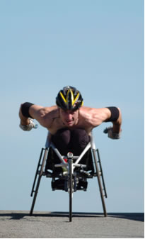
To the left is a shot of my race preparation, again shot by Guy Cope. Surprisingly this was in Raskelf, North Yorkshire and not some warmer climate.

Perhaps as a result of a week of inactivity through illness, before the Great North Run, I felt rested and energised on the morning of the race. The conditions were perfect and as we lined up for the gun, the rivalry and competition was intense for this final outing in our racing calendar. I always have a good start at the Great North, as my body weight, a mere 60.5kg, and streamlined position, help me attain a high rolling speed on the fast downhill section, where other racers weighing 45 to 55kg find it difficult to hold their pace. After this quick section came the long arduous hills that define this event. Here, the lighter racers usually make up ground, but this year I was leaner and stronger than ever, and refused to look back as I powered into 3rd place. The leading two were out of sight, but the bit was firmly between my teeth. I crossed the line in 53mins, a huge 6mins and 19s faster than in 2003, and made the podium in 3rd place.

In an attempt to bring my newsletters into the 21st century, I have now launched my own web site where I have tried to provide information about my life on and off the track. There are also some links to my sponsors and friends, along with a gallery. Ultimately, I hope to put the current season’s reviews on the site and to issue electronic copies, but one step at a time. Please take a look, any feedback would be much appreciated. You can find me at “www.jasonrichards.co.uk”

After a month off, I am now 3 weeks back into my winter training, involving nine sessions over six days, with only a single (well earned) day of rest. If I am to achieve the standards for the European Championships in 2005, I must notch up my training another gear. As a result I currently ache, am full of cold and wondering why I put myself through this. But the highs of success and achievement far outweigh the suffering and occasional lows, and the passion that fuels this journey grows ever stronger, along with the desire to be on the plane to Beijing in 2008.
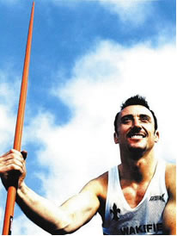

Once again, many thanks to all who have helped and supported me.

Jason Richards
November 2004

